2.Data Pre-Processing:

For this question I worked with the suggested dataset, mainly because it needed a good amount of processing in order to be usable, and that wasn’t the same for many of the ones that I came across.

Here is how the chronic kidney disease dataset was described on Kaggle:

*The data was taken over a 2-month period in India with 25 features ( eg, red blood cell count, white blood cell count, etc). The target is the 'classification', which is either 'ckd' or 'notckd' - ckd=chronic kidney disease.*

Here is a full list of each column in the dataset:

|  |  |
| --- | --- |
| age - age | sod - sodium |
| bp - blood pressure | pot - potassium |
| sg - specific gravity | hemo - hemoglobin |
| al - albumin | pcv - packed cell volume |
| su - sugar | wc - white blood cell count |
| rbc - red blood cells | rc - red blood cell count |
| pc - pus cell | htn - hypertension |
| pcc - pus cell clumps | dm - diabetes mellitus |
| ba - bacteria | cad - coronary artery disease |
| bgr - blood glucose random | appet - appetite |
| bu - blood urea | pe - pedal edema |
| sc - serum creatinine | ane - anemia |
|  | class - classification |

  
I worked from left to right. I got the mean of all ages after removing the ‘NA’s’ and them with the mean age of all participants.

I repeated the same steps for each of the following columns until I got to ‘rbc’ (red blood cells).

In ‘rbc’ we meet ‘characters’ for the first time. My approach here was what was presented to us in class – that in order to make the code machine readable the bivalent values should be changed to either a numerical ‘1 and 0’ or a logical ‘True and False’.

I assigned ‘normal’ to ‘1’ and ‘abnormal’ to a ‘0’ and changed the values for the whole column, and subsequently assigned ‘NA’ to ‘0’.

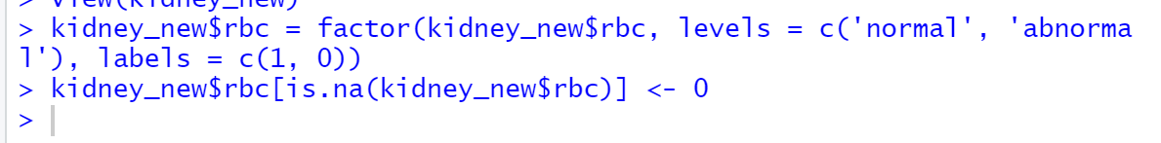This process was repeated for another four columns, the only difference being the nature of the character strings being replaced:

the ‘pcc’ and ‘ba’ columns (0,1) columns were ‘notpresent’ and ‘present’ respectively.

The next six columns were treated the same way as the first five, by calculating the mean value of each column and replacing the ‘NA’ values with the result.

Interestingly, the ‘pcv’ column threw me a curveball, as though it was a list of integer values they were listed as being ‘characters. I assume that was because they were entered into the dataset from user input. This meant I had to change all the values to ‘numeric’ before I could find the mean and so fill in all the empty boxes.

The next two columns were numerical and the remaining eight were all characters – all of them bivalent in nature. They had different permutations but were all either true or false in nature – ‘yes/no’, ‘good/poor’ and ‘ckd/notckd’.

All columns were assigned ones and zeros and NA’s were removed.

By the end of this process I had a dataset that was machine ready with all NA values removed and all columns being ‘numeric’ in form.